**PART 1**

A)

Write a multithreaded program that calculates various statistical values for a list of numbers (try small/large/very large numbers). T

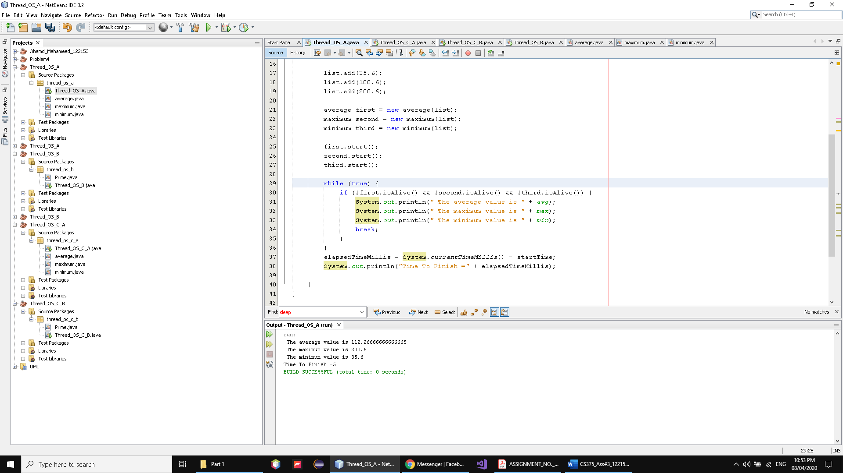

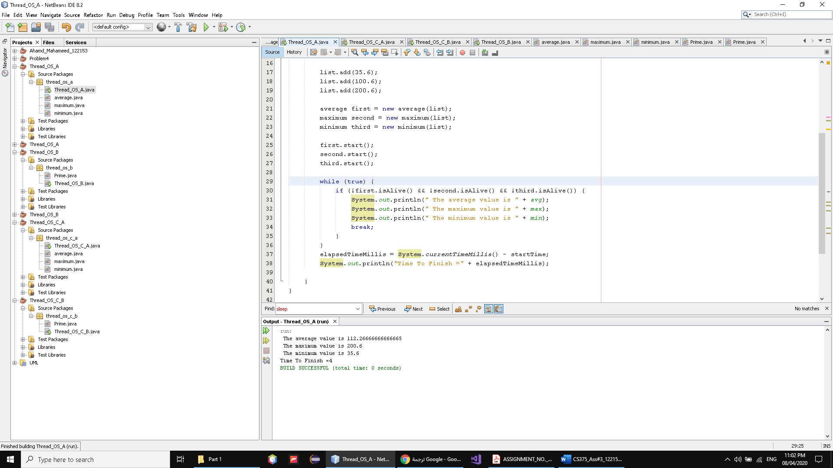

As we see we have 3 classes extend thread and override the run and make them run together and got right result and there comment code to check got right result by main thread and the time of execution 5 to 4 based on speed

B)

Write a multithreaded program that outputs prime numbers. This program should work as follows: The user will run the program and will enter a number as an input. The program will then create a separate thread that outputs all the prime numbers less than or equal to the number entered by the user.

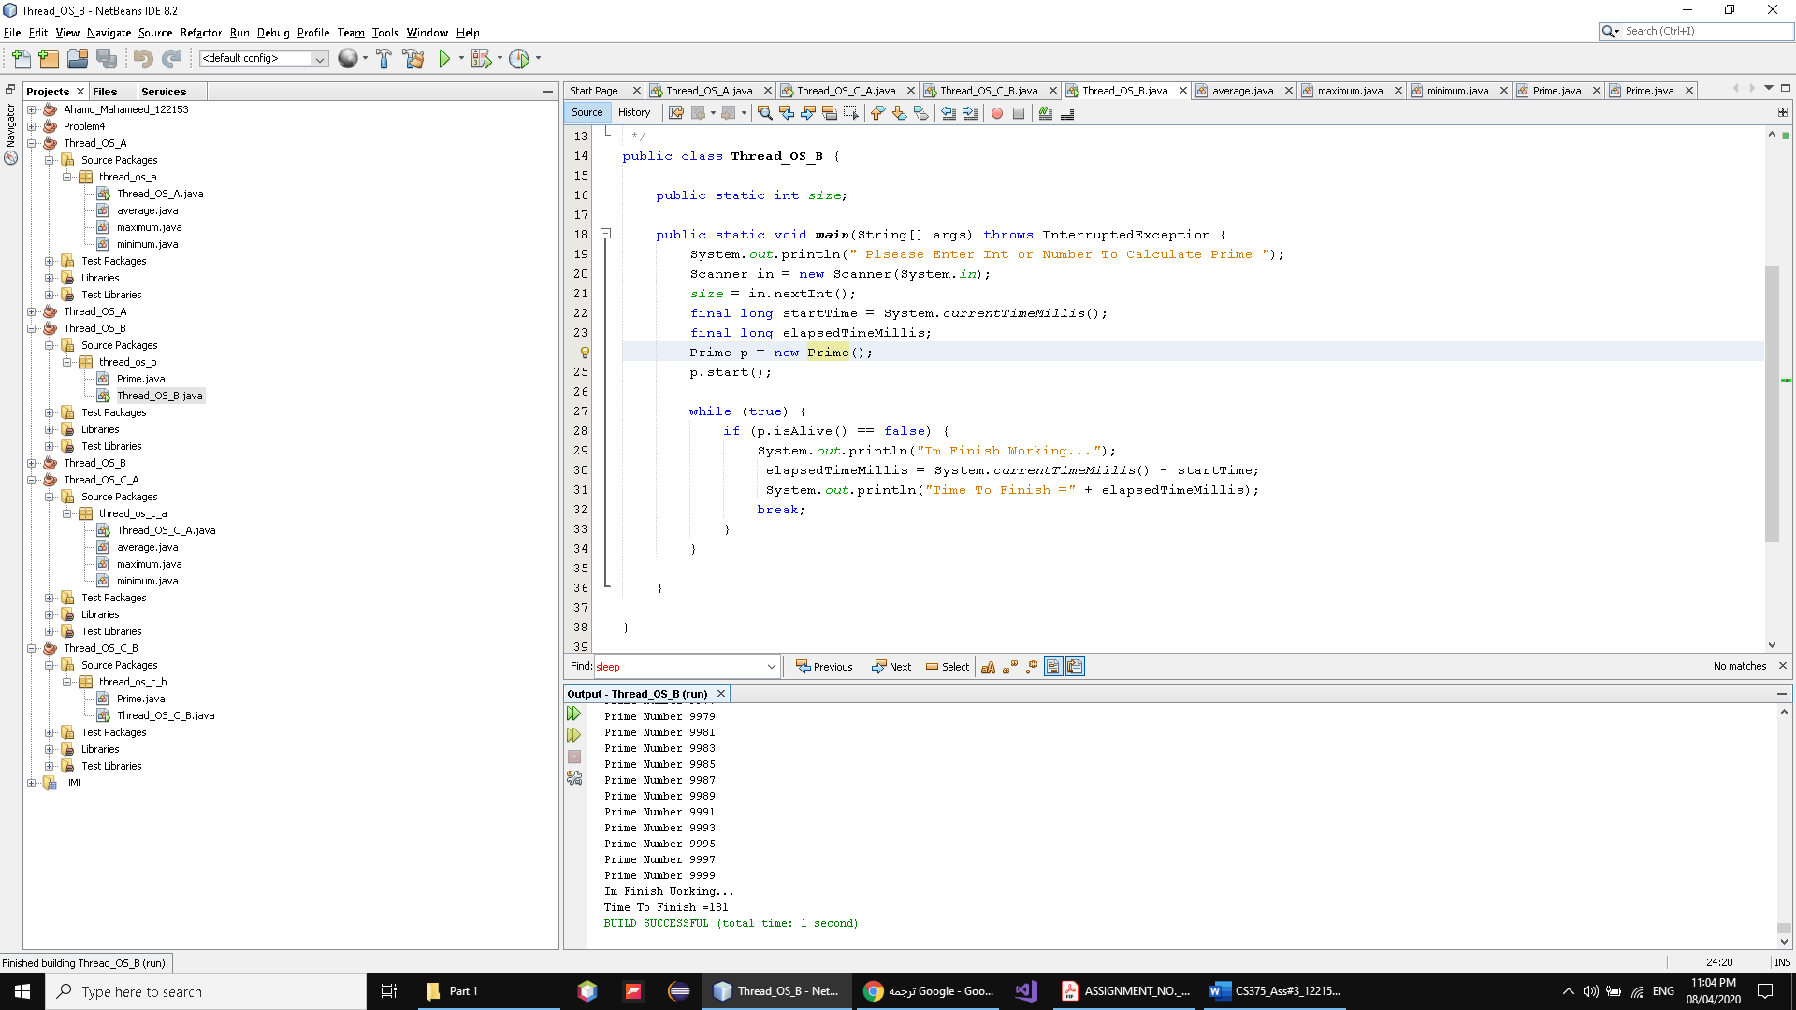

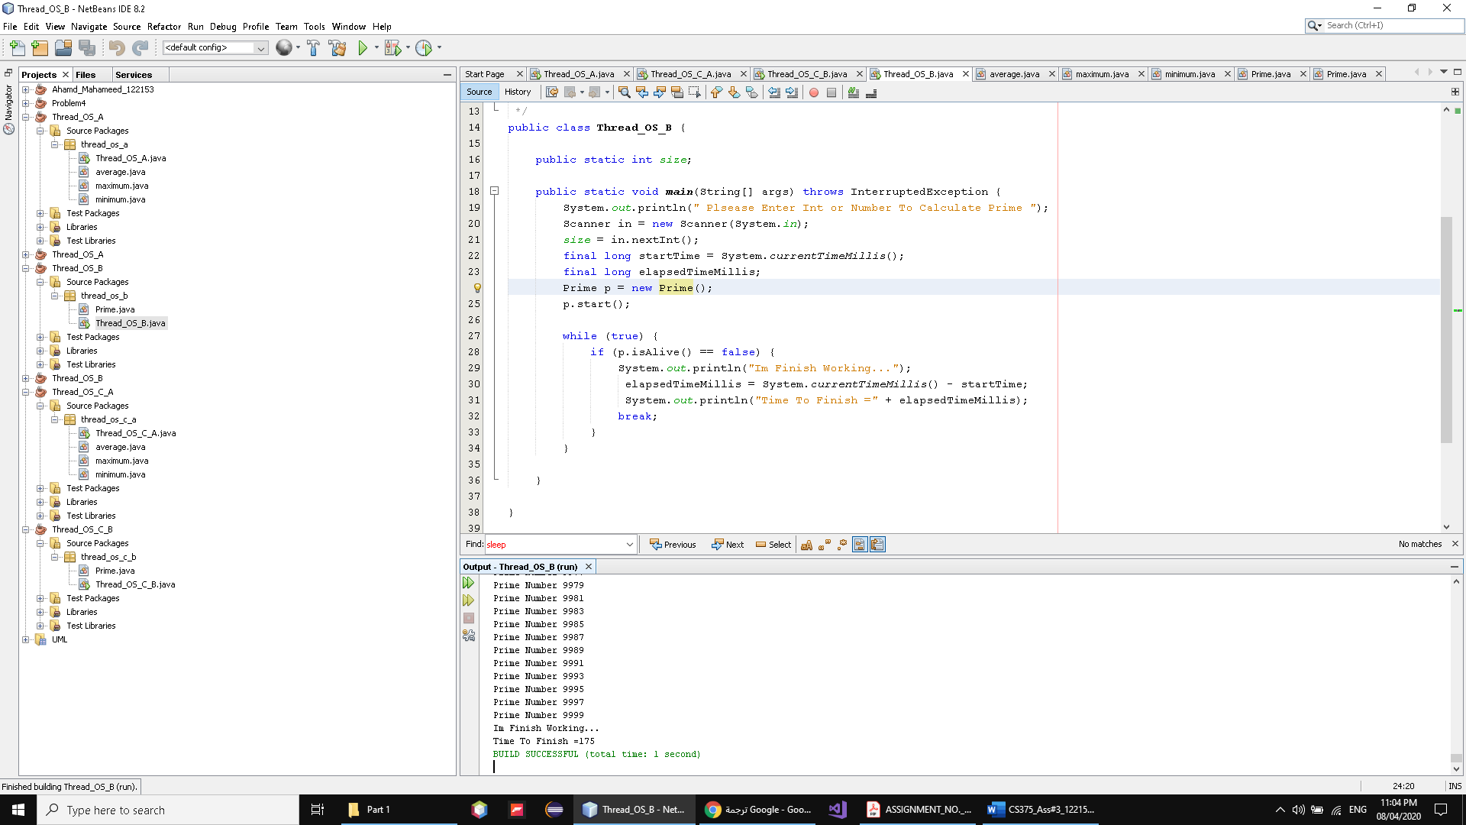

As we see we have 1 classes extend thread and override the run and make him run and got right result by main thread and the time of execution 170 to 190 this range based on speed

And we start calculate time after user enter number to be accurate to know who fast (Thread,single )

C)

c. Solve the previous problems without using threads. Use the time function with each part (a, b and c) and show, for each one, what is the exact execution time? Is there any difference? Why? You have to answer these questions in your report.

**A**

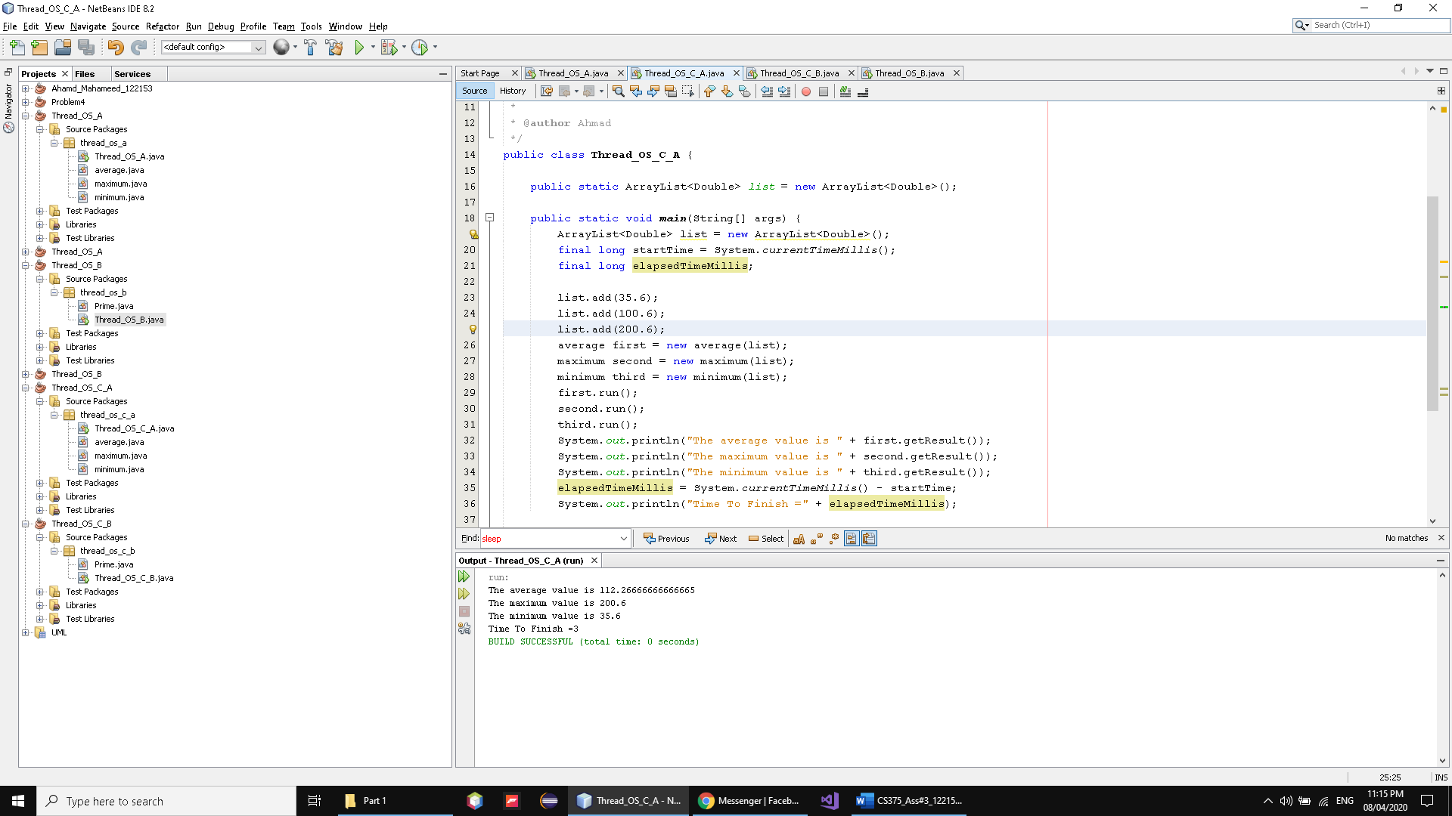

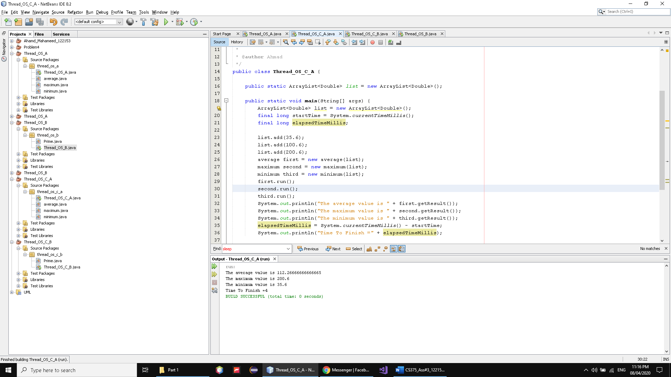

what is the exact execution time?

As we see from 3 to 4

Is there any difference?

yes

Why?

Because before use thread and here single

And there is weight to create the thread and the thread not be fast all the time

We should consider the way the work and how to make them

More efficient

And this is lightweight operation to exute

**B)**

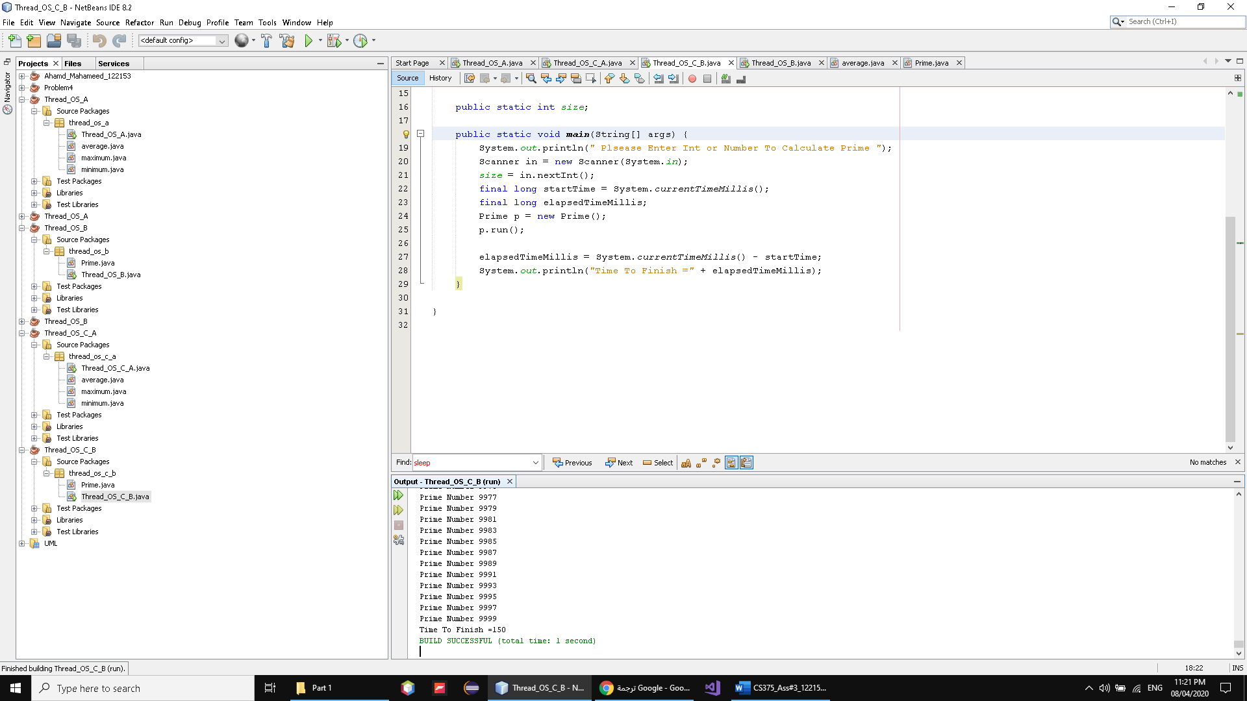

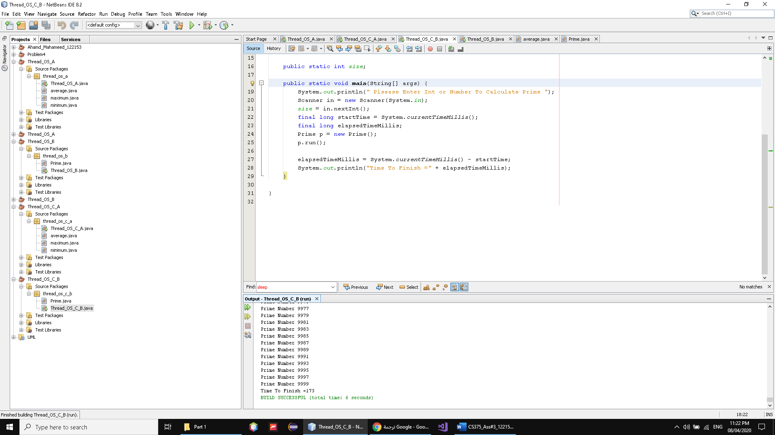

what is the exact execution time?

As we see from 150 to 17(0-9)

Is there any difference?

yes

Why?

Because before use thread and here single

And there is weight to create the thread and the thread not be fast all the time

We should consider the way the work and how to make them

More efficient and here there is one function to exute same time

Its like sequential because that not efficient to use thread

And this is lightweight operation to exute